**CYCLE 2**

1. **Create an html page to display the following nested list :**

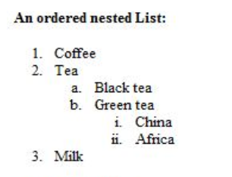

**Program**

<html>

<head>

<title>img</title>

</head>

<body>

<b>An ordered nested list:</b>

<ol type="1">

<li>Coffee

<li>Tea

<ol type="a">

<li>Black tea

<li>Green tea

<ol type="i">

<li>China

<li>Africa

</ol>

</ol>

<li>Milk

</ol>

</body>

</html>

**Output**

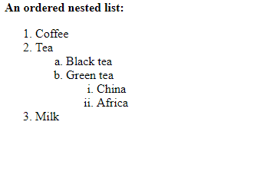

**2**. **Create links to three different pages on three different websites that should all open in a new window.**

**Program**

<html>

<head>

<title>links</title>

</head>

<body>

<a href="https://mail.google.com">gmail</a>

<br><br>

<a href="https://www.mgu.ac.in">M G University</a>

<br><br>

<a href="https://lbscentre.in/">LBS center for science and technology</a>

</body>

</html>

**Output**

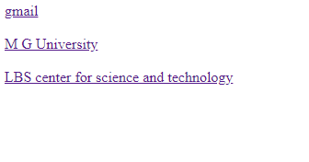

**3. Create a page with a link at the top of it that when clicked will jump all the way to the bottom of the page.**

**Program**

<html>

<head>

<title>links</title>

</head>

<body>

<a href="#bottom">Click here to jump to the Bottom of the page</a>

<p>some text</p>

<p>some text</p>

<p>some text</p>

<p>some text</p>

<p>some text</p>

<p>some text</p>

<p>some text</p>

<p>some text</p>

<p>some text</p>

<p>some text</p>

<p>some text</p>

<p>some text</p>

<p>some text</p>

<P>some text</p>

<p>some text</p>

<p>some text</p>

<p>some text</p>

<p>some text</p>

<p>some text</p>

<p>some text</p>

<a name="bottom">The bottom of the page</a>

</body>

</html>

**Output**

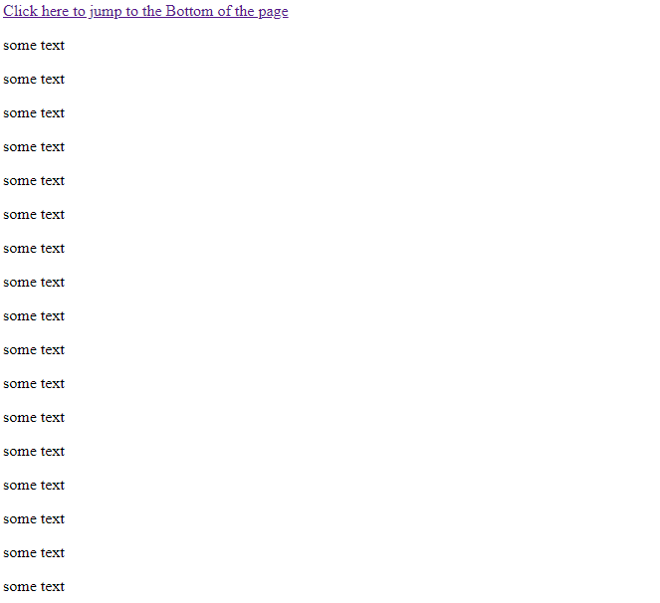

**4. Display three different images. Skip two lines between each image. Each image should have a heading.**

**Program**

<html>

<head>

<title>imgs</title>

</head>

<body>

<h1>Image 1</h1>

<img src="C:\Users\Admin\Downloads\wallpapers\dahlia-red-blossom-bloom-60597.jpeg" width="100" height="100"><br><br>

<h1>Image 2</h1>

<img src="C:\Users\Admin\Downloads\wallpapers\hd-nature-wallpapers-20.jpg" width="100" height="100"><br><br>

<h1>Image 3</h1>

<img src="C:\Users\Admin\Downloads\wallpapers\download (5).jpg" width="100" height="100">

</body>

</html>

**Output**

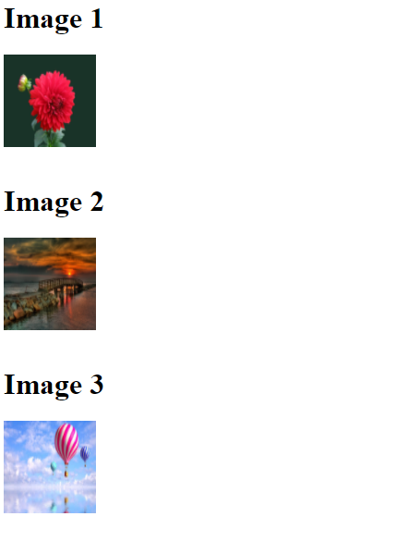

**5. Display an image that when clicked will link to a search engine of your choice in a different window.**

**Program**

<html>

<head>

<title>img</title>

</head>

<body>

<a href="https://www.google.com/">

<img src="C:\Users\Admin\Downloads\wallpapers\download (5).jpg"></a>

<p>click on the image to be taken to the google search engine.</p>

</body>

</html>

**Output**

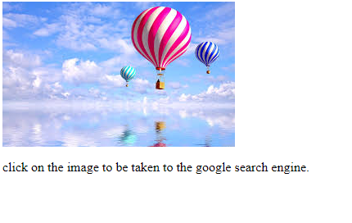

6. **Create the following Html Page using appropriate form controls :**

**Program**

<html>

<head>

<title>form</title>

</head>

<body bgcolor="yellow" >

<table align="center">

<center><h2>Fruit Survey</h2></center>

<tr><td>Name</td><td><input type="text" placeholder="lain Tench" name="txt1"maxlength=15></td></tr>

<tr><td>Address</td><td><input type="text" placeholder="10 Avenue" name="txt2" maxlength=15></td></tr>

<tr><td>Email</td><td><input type="text" name="txt3" maxlength=15><font color=red>Missing</font></td></tr>

<tr><td>How many pieces of fruit<br>do you eat per day?</td>

<td><input type="radio" name="txt4" value="zero">0<br>

<input type="radio" name="txt4" value="one">1<br>

<input type="radio" name="txt4" value="two">2<br>

<input type="radio" name="txt4" value="more">More than 2</td></tr>

<tr>

<td>My favourite fruit</td>

<td><textarea rows="4" cols="12" name="My favourite fruit">Apple

Banana

Plum

Pomegranate

orange

</textarea></td></tr>

<tr><td>Would you like a<br>brochure ?</td><td><input type="checkbox" name="Yes" value="No"></td></tr>

<tr><td></td><td><input type="submit" value="submit"></td></tr>

</table>

</form>

</body>

</html>

**2.6.1.html**

<html>

<head>

<title>fruit</title>

</head>

<body bgcolor="red">

<center>

<h1>The World of Fruit</h1></center>

</body>

</html>

**2.6.2.html**

<html>

<head>

<title>con</title>

</head>

<frameset rows="10%,*">

<frame src="2.6.1.html">

<frame src="2.6.html">

</frameset>

</html>

**Output**

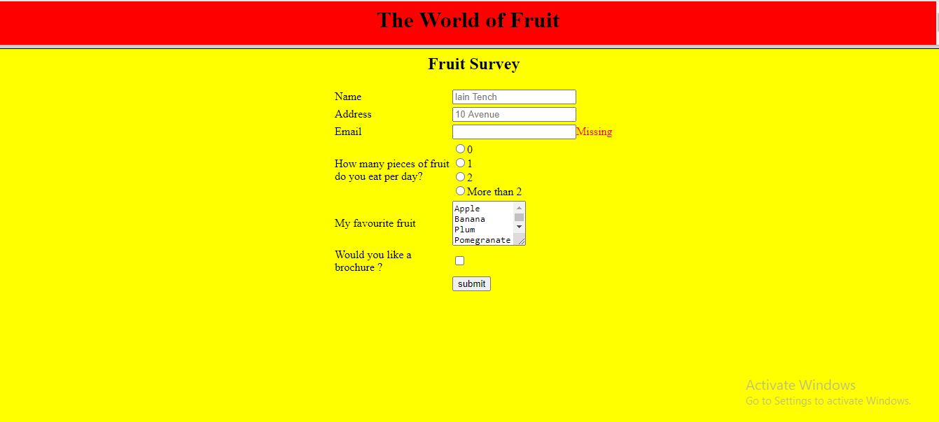

**7. Create an image map for ‘Kerala Map’. Map at least 3 districts so that when you click on that particular district the details regarding that district(eg: population, Area, Tourist Spots(with images), Monuments, Interesting Facts ) should be displayed on a new page.**

**Program**

<html>

<head>

<title>map</title>

</head>

<body>

<h1>KERALA MAP</h1>

<map name="kerala">

<area="circle" coords="25,443,10" href="kottayam.html"></area>

<area="circle" coords="310,405,12" href="idukki.html"></area>

<area="circle" coords="259,391,20" href="ekm.html"></area>

</map>

<img src="C:\Users\Admin\Downloads\map.jpg" usemap="#kerala">

</body>

</html>

**Kottayam.html**

<html>

<head>

<title>map</title>

</head>

<body>

<h1 align="center"><font color="red" size=30>KOTTAYAM</font></h1><br>

<b>Kottayam is a city in the Indian state of Kerala. Kottayam literally means the interior of a fort—Kotta + Akam. Flanked by the Western Ghats on the east and the Vembanad Lake and paddy fields of Kuttanad on the west, Kottayam is a place that is known for extraordinary qualities. Wikipedia

</b><br>

<h1>POPULATION</h1><br>

<b>As of 2001 India census,[13] Kottayam Urban Agglomeration had a population of 172,878, while Kottayam district had a population of 1,974,551. The population of Kottayam municipality was 136,812. Males constituted 62% of the population and females 38%. Population growth in the district had a diminishing trend with a decadal population growth rate of 6.5% compared to 9.35% across the decade 1991–2000.[14] Population growth in the municipality is due to migration for employment. Kottayam District is ranked first in literacy, with 95.9% literacy compared to 90.92% for Kerala State and 65.38% for India (2001 census).[4] More recently,[when?] Kottayam town and district is ranked fourth in literacy in India with a literacy rate of 97.21%.[citation needed]

</b><br>

<h1>AREA: 77.8 km²</h1><br>

<h1>TOURIST SPOTS</h1><br>

<ul>

<li><h2>MARMALA WATERFALLS</h2><br><br>

<img src="C:\Users\Admin\Documents\html2020\Marmala-waterfalls-kerala.jpg"><br><br>

<b>Located at a distance of few kms from Erattupetta in Kottayam inside a private rubber estate, Marmala Waterfalls are popularly known as the ‘enchantress of the jungle’. Plummeting from a height of 200 feet, the unblemished clear waters create and aura of mist around them.

</b><br><br>

<li><h2>POONJAR PALACE</h2><br><br>

<img src="C:\Users\Admin\Documents\html2020\palace.jpg"><br><br>

<b>A huge majestic palace bounded by a boundary of massive walls is Poonjar Palace situated in Meenachil Taluka. The palace is adorned with a fascinating collection of various type of furniture and antiques which includes grand chandeliers, jewelry boxes, statues, grain measurer, weapons and palm leaf engravings.

</b>

</ul>

</body>

</html>

**Idukki.html**

<html>

<head>

<title>map</title>

</head>

<body>

<h1 align="center"><font color="red" size=30>IDUKKI</font></h1><br>

<b>Idukki district is a densely forested, mountainous region in the south Indian state of Kerala. In the north, Anamudi mountain towers over Eravikulam National Park, where the rare, blue Neelakurinji flower blooms every 12 years. Nearby, Munnar is a hill station known for its sprawling tea plantations and Tea Museum. Farther south is the vast, curved Idukki Dam and Periyar National Park, a tiger and elephant reserve. ― Google

</b><br>

<h1>POPULATION: 11.1 lakhs

</h1><br>

<h1>AREA: 77.8 km²</h1><br>

<h1>TOURIST SPOTS</h1><br>

<ul>

<li><h2>IDUKKI ARCH DAM</h2><br><br>

<img src="C:\Users\Admin\Documents\html2020\dam.jpg"><br><br>

<b>Built across the Kuravan and Kurathi hills at a height of about 550 feet, the Idukki Arch Dam is an architectural genius, for the rugged terrain along which it is built. The natural beauty surrounding the dam is breath-taking.

</b><br><br>

<li><h2>HILL VIEW PARK</h2><br><br>

<img src="C:\Users\Admin\Documents\html2020\1423_20200526135223.jpg"><br><br>

<b>With spectacular views of the Cheruthoni and Idukki Dams, the Hill-view Park serves as a famous tourist destination of Idukki. One can also spot diverse wildlife in its belt natural habitat.

</b>

</ul>

</body>

</html>

**Ekm.html**

<html>

<head>

<title>map</title>

</head>

<body>

<h1 align="center"><font color="red" size=30>ERANAKULAM</font></h1><br>

<b>Sprawling, residential Ernakulam is known for Marine Drive, a busy waterfront promenade where boats offer backwater cruises. The Kerala Folklore and Hill Palace museums explore local heritage through art and antiquities. Shops along Broadway and on MG Road sell fabrics, crafts, and spices, while modern Lulu Mall also has a cinema and an ice rink. Simple eateries serve Keralan specialties and South Indian seafood. ― Google

</b><br>

<h1>POPULATION: 6.77 lakhs (2011)

</h1><br>

<h1>AREA: 3,032 km²

</h1><br>

<h1>TOURIST SPOTS</h1><br>

<ul>

<li><h2> Cherai Beach

</h2><br><br>

<img src="C:\Users\Admin\Documents\html2020\hjkjk.jpg"><br><br>

<b>Located on the north end of Vypin island in Kochi, Cherai beach is a 15 km stretch of wild and rugged beauty. Although not overwhelmed by hotels or major restaurants, the beach is dotted with small shacks selling local snacks like pakoras and chips. Stunning lagoons, wide paddy fields and coconut grooves adorn the road to the beach. Ernakulam sightseeing is not complete without a visit to Cherai beach.

</b><br><br>

<li><h2> Vypeen Island

</h2><br><br>

<img src="C:\Users\Admin\Documents\html2020\download (2).jpg"><br><br>

<b>Vypeen is one of the popular places to visit in Ernakulam in one day. A short and beautiful ferry ride from the city will take to this serene island which is dotted with beaches, backwaters and an array of restaurants and hotels. A desktop worthy scenery away from the bustling environment is what makes Vypeen island one of the best places to visit in Ernakulam for lovers.

</b>

</ul>

</body>

</html>

**Output**

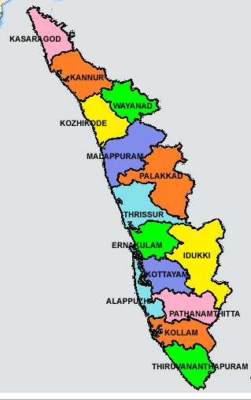

**8. Construct this puzzle looking thing :**

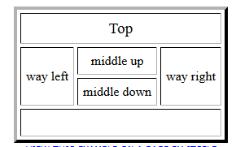

**Program**

<html>

<head>

<title>links</title>

</head>

<body>

<table border=2>

<tr><td align="center" colspan=6>Top</td></tr>

<tr><td rowspan="2">way left</td>

<td colspan="2">middle up</td>

<td rowspan="2" >way right</td>

</tr>

<td colspan="2">middle down</td>

</tr>

<tr><th colspan="6">down</th>

</table>

</body>

</html>

**Output**

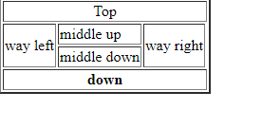

**9. Make up three image links for 3 web browsers and put them in a borderless table. Construct the table so that there is just a little space between the images.**

**Program**

<html>

<head>

<title>fruit</title>

</head>

<body>

<table>

<tr>

<td><a href=https:/www.google.com><img src="C:\Users\Admin\Downloads\wallpapers\hd-nature-wallpapers-12.jpg" height=200"></a></td>

<td><a href=https:/www.gmail.com><img src="C:\Users\Admin\Downloads\wallpapers\hd-nature-wallpapers-11.jpg" height=200"></a></td>

<td><a href=https:/www.yahoo.com><img src="C:\Users\Admin\Downloads\wallpapers\hd-nature-wallpapers-22.jpg" height=200"></a></td>

</tr>

</table>

</body>

</html>

**Output**

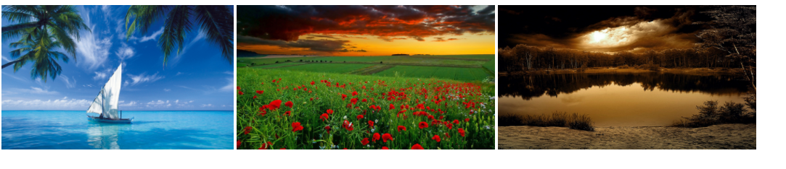

**10. Create the following html page using frames :**

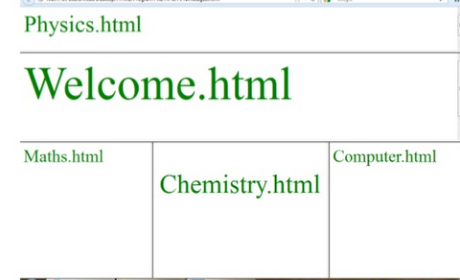

**Program**

<html>

<head>

<title></title>

</head>

<frameset rows="20%,30%,*" border=3>

<frame src="phy.html">

<frame src="wel.html">

<frameset cols="30%,30%,*">

<frame src="math.html">

<frame src="che.html">

<frame src="com.html">

</frameset>

</html>

**Output**

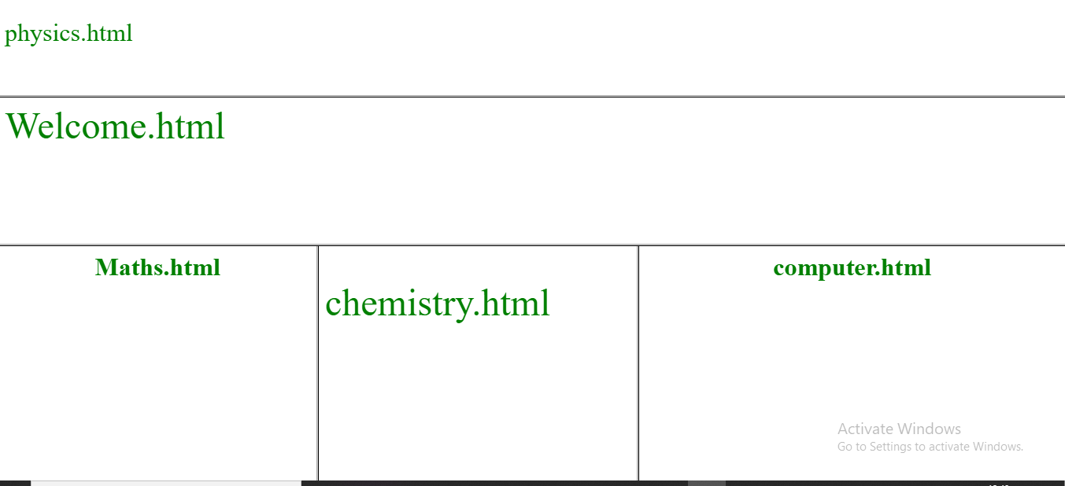

**11. Create an HTML page using frames which is similar to the following one.**

**In the left frame provide hyperlinks to 3 important monuments in world. On clicking that hyperlink an image of the monument should be displayed in right frame with suitable description.**

**Program**

**2.11.html**

<frameset cols="30%,*" border="1">

<frame src="links.html">

<frame src="bg.html" name="home">

</frameset>

**Bg.html**

<html>

<head>

<title>img</title>

</head>

<body bgcolor="skyblue">

</body>

</html>

**Links.html**

<html>

<head>

<title>img</title>

</head>

<body>

<ul>

<h3>

<li><a href="p1.html" target="home">India Gate</a><br><br>

<li><a href="p2.html" target="home">Qutub Minar</a><br><br>

<li><a href="p3.html" target="home">Taj Mahal</a><br>

</h3>

</ul>

</body>

</html>

**P1.html**

<html>

<head>

<title>img</title>

</head>

<body>

<font size=15 color=red>India Gate</font><br>

<img src="C:\Users\Admin\Documents\html2020\200px-India_Gate_in_New_Delhi_03-2016.jpg">

<h3>The India Gate (formerly known as the All India War Memorial) is a war memorial located astride the Rajpath, on the eastern edge of the "ceremonial axis" of New Delhi,[1] formal called Kingsway .

It stands as a memorial to 70,000 soldiers of the British Indian Army who died in between 1914 and 1921 in the First World War, in France, Flanders, Mesopotamia, Persia, East Africa, Gallipoli and elsewhere in the Near and the Far East, and the third Anglo-Afghan War.

13,300 servicemen's names, including some soldiers and officers from the United Kingdom, are inscribed on the gate.[2] Designed by Sir Edwin Lutyens, the gate evokes the architectural style of the triumphal arch such as the Arch of Constantine, in Rome, and is often compared to the Arc de Triomphe in Paris, and the Gateway of India in Mumbai.</h3>

</body>

</html>

**P2.html**

<html>

<head>

<title>img</title>

</head>

<body>

<font size=15 color=red>Qutub Minar</font><br>

<img src="C:\Users\Admin\Documents\html2020\download.jpg">

<h3>Built in the early 13th century a few kilometres south of Delhi, the red sandstone tower of Qutb Minar is 72.5 m high, tapering from 2.75 m in diameter at its peak to 14.32 m at its base, and alternating angular and rounded flutings. The surrounding archaeological area contains funerary buildings, notably the magnificent Alai-Darwaza Gate, the masterpiece of Indo-Muslim art (built in 1311), and two mosques, including the Quwwatu'l-Islam, the oldest in northern India, built of materials reused from some 20 Brahman temples.

</h3>

</body>

</html>

**P3.html**

<html>

<head>

<title>img</title>

</head>

<body>

<font size=15 color=red>Taj Mahal</font><br>

<img src="C:\Users\Admin\Documents\html2020\220px-Taj-Mahal.webp">

<h3>

An immense mausoleum of white marble, built in Agra between 1631 and 1648 by order of the Mughal emperor Shah Jahan in memory of his favourite wife, the Taj Mahal is the jewel of Muslim art in India and one of the universally admired masterpieces of the world's heritage.

</h3>

</body>

</html>

**Output**

